Market carnage (Opportunity) 2020: the way forward | Abstract  My views on the current crisis in Market and a few pointers for Investors.  Venkatesh Jayaraman  ( @EWFA_ )

Market Carnage (Opportunity) 2020 : the Way Forward
-Venkatesh Jayaraman ( @EWFA_ )

Disclaimer
- This article/write up is intended to share my views on the current market situation, how it CAN be in the coming days and an overview of few options for a retail investor
- Read the words ‘can’, ‘may’, ‘could’, ‘might’ in the context of forward looking i.e. Projections
- This is not intended to be a kind of prediction of market direction or returns in the coming days or how best/worst can the situation become, but intends to cover all possibilities
- Please do not take any investment decision based on this work, but do have your own views and strategy from these insights

Contents
0
First Things First! 2
History of Indices hiding Lower Circuit 3
What happened in 2008? 3
What is Happening in 2020? 4
Impact on Markets 4
What happened to Indian markets on 13th March 2020? 5
Views from Tony Robbins 6
What Should an Investor do Now? 6
Impact of This Situation 7
How Big is the Impact? 7
Economy 7
Government 9
How Long is the Impact? 9
So, is the Carnage expected to continue? 9
The Impact will end soon as US is making lot of financial Stimulus… 10
Positives for the moment 10
Human Emotions 10
Investor Categories 12
Mutual Funds or Direct Equity Investors 13
Years of Experience 14
Investing Strategy 15
Pointers for DIY Investment 15

First Things First!
The financial markets globally were in turmoil in the last few days and particularly in the second and third week of March. There are buzzing term like markets crashed, correction, bear market, recession, trading suspension, markets hit Lower Circuit (LC) etc. floating around social media and widely discussed in news channels. So, before we dive in into the main part of the article, let us take 2 minutes on these jargons:
Market crash
- Indices drop severely in a day or course of few days
- This crash is more sudden than a gradual one
- This does not have a numerical quantification in terms of %-age of fall
Correction & Bear Market
Adding numerical quantification to market crash gives better insights, accordingly comes two specific terms
- Correction: Indices fall by 10% from its peak value
- Bear Market: Indices fall by 20% from its peak value
Recession
- A significant decline in economic activity spread across the economy lasting for several months
- Normally measured by GDP (If i remember well, of my early reads... A economy is in recession, if two successive GDP measure are in declining. Accept this line with a pinch of salt)
- A market crash CAN lead to recession, but not necessarily
Lower Circuit (LC)
- When the indices fall below 10% on a day, then trading is halted in the exchanges
- The duration of this halt is different based on the %-age decline and the timing of the day it happens
- Below is the summary of the LC trading halt and duration for Indian markets
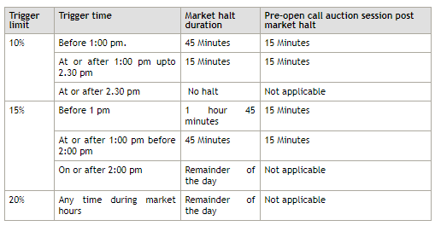
Source: https://www1.nseindia.com/products/content/equities/equities/circuit_breakers.htm

History of Indices hiding Lower Circuit
The Indian markets have hit Lower Circuit and trading suspended, 5 times in the past.
Instance # | Date | Reason
1 | April 28, 1992 | Harshad Mehta Scam
2 | May 17, 2004 | Election result uncertainty
3 | October 17, 2007 | P-Notes issue
4 | January 22, 2008 | Subprime crisis
5 | March 13, 2020 | Recent Crash

It is for the first time in 2020 that the markets were in jitters due to a global health issue. Very interestingly, LC and suspension of trading happened in many global markets including US on 12/13 of March 2020.
Note: Many would ask about no-mention of markets in 2000 IT meltdown, or markets post Sep 11, 2001 twin tower attacks. Yes, Markets did get affected. The above five instances are only focussing on instances, when markets hits LC and trading halted.
I had the opportunity to witness all these 5 instances though not as an investor all the times!
- In 1992, as a Son, I still remember the day when by Dad came back from office and mentioned the blood bath in market and impact on his portfolio
- In 2004 and 2007, I was not invested but was observing the situation
- In 2008, I just started investing (Trading would be the right world!) a week back
- In 2020, As an investor after being in markets for ~12 years

What happened in 2008?
I navigated the markets through the melt down that started from Jan 2008 as an investor. The melt down started within a few days of me entering the markets. I quickly summarize as to what I witnessed or went through in 2008.
- Apart from the markets hitting LC on the third week of January 2008, what happened for the next 10-12 months is very important
- Markets did recover a bit after LC, but did not touch the previous heights
- Markets/Stocks would fall 4% and rise by 1 or 1.5 percent over the next couple of days and cycle repeated with index/stock prices drifting continuously to lower values
- A couple of banks failed in US, which brought in more carnage in the second half of 2008
- It was like a “Slow and Painful Death”, which lasted around 15 months
- All the while there was assurance from various stakeholders i.e. Investors, industrialists etc, including Government that India’s economy and growth story was structurally intact
- True, but India cannot escape the impact of global developments
- At one stage, the indices were declining continuously for 10-12 trading days
- Once the psychological barrier of 10,000 points of Sensex was breached the carnage became bigger and continued till the end of the year, with the lowest somewhere in end of November
- Form end of November 2008, the Indices gradually went up till Jan 2009, when the Satyam scam came up and all hell broke loose again…this time it was more specific Indian markets
- However, the story changed completely post-election results in April 2009
The story depicted in the chart below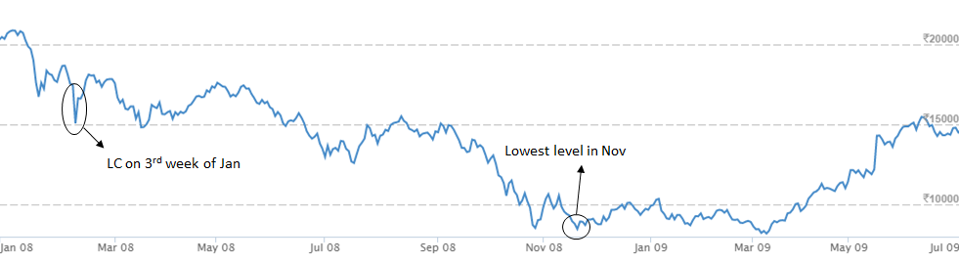
Chart source: Moneycontrol.com
What were the mistakes & Learnings from 2008?
(This includes both my mistake and my general observation from other market participants)
- Buying more to average on every dip
  - There were too many dips in this 15-month journey, with stock prices not recovering even to the purchase price of the last lot
  - Every lot purchased on dips was showing loss within a few days of purchase!
- Borrowing to buy stocks at lower prices and make quick gains
  - Stock prices still went down continuously week on week and hence could not sell stocks for profit in a few days and return the borrowed money!
  - While the stocks were locked, borrowed money had to be returned
- The carnage was so much, that most of the stocks lost 1 digit in a few weeks! Stock trading at INR 1000, became INR 300 in a matter of few days
- Investing on any company that appeared cheap without any attention to fundamentals
- Buying penny stocks in huge volumes with hopes of these holdings becoming 10x or even 100x!
- Asian/Indian markets taking cue from US markets the previous day and US markets taking cues from Asian/Indian market the following day – It was a endless Negative destructive loop

What is Happening in 2020?

Impact on Markets
- Chinese Markets
  - The Chinese economy was the worst hit, in terms of shutting many cities and factories
  - Due to this, the Industrial activities were affected to a great extend
  - But very interestingly, the Chinese market did not see a big impact and almost remained flat in this 3-month period
- Global Markets
  - The financial markets globally were in turmoil in the last few days and particularly in the 2nd and 3rd week of March
  - The falls had been steep (in % downfall) and very swift (in a span less than 2 week) than what was witnessed in 2008
- Indian Markets
  - The situation was like global peers in terms of downfall and timelines
  - Sensex came down from all time high of 41,000 points to 29,000 in the last one-month period
    - March 12: Sensex lost close to 3000 points
    - March 13: Indices closed in a few minutes after losing 10% and touching the Lower Circuit
  - The LC on March 13 was widely expected as the American markets too had the same fate the previous day i.e. Hitting lower circuit and trading suspended
  - Post re-open contrary to expectations the market steeply recovered closing +4%
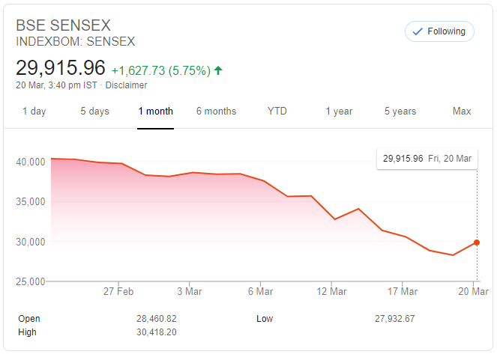
Source: Google

What happened to Indian markets on 13th March 2020?
- It was a wild roller coaster! Indices breached -10% and trading was suspended
- Post Lower Circuit when the market re-opened it raised steeply and steadily for the entire day before closing 4%
- While this may be good, one aspect to be noted is that “big” money entering the markets would have the primary reason for his increase from re-open till closure of the day
- There were many possible reasons: I saw it could be due to short covering, large FII exit in leading to LC and huge DII purchase post re-open
- A few other reasons that twitter friends shared…LIC would have come to rescue to remove the panic from markets
- The LIC effect seems to be more convincing for such a bounce back
- The same day American markets also closed with huge gains
But the question still remains…
When markets opened on 13th March 2020 at 9.15 am, it hit 10% down before opening again after 45 mins. Markets recovered 10% loss before closing ~4% up for the day.
What happened in this 45 minutes? What was not attractive and traded -10% became attractive after 45 minutes as a buy?
Answer may be known in the coming days or not be known at all…

Views from Tony Robbins
Before proceeding further on how to position ourselves, let me share a few points from a book by Tony Robbins. He had written a book “Unshakeable” with two chapters entirely for dealing with stock market crashes and bear markets. I had mind-marked these to be re-read during such crisis.
I re-read recently and below is a high-level summary from those 2 chapters. Though these are in American context/markets the essence of message remains the same!
- Since 1900, on an average there was 1 correction every 1 year and an average correction lasted for 54 days (< 2 Months)
- Less than 20% of all corrections turned into bear markets
- Nobody can predict, if the markets will rise or fall
- Stock markets rises over time despite many short-term setbacks
- Since 1900, there was bear market every 5 years on an average
- Most important, bear markets don’t last long by varies from 45 to 694 days (i.e. 1.5 month to 2 years)
- Best opportunities come at time of maximum pessimism
- When pessimism becomes optimism, bear markets become bull markets
- Market turmoil is not something to fear, but the greatest one-time opportunity to leapfrog to financial freedom
- You never know what stock markets will do, but that uncertainty is not an excuse for inaction
- If you make a wrong decision during bear markets, it can be catastrophic and can take you back several years, but making a right decision will be very rewarding

What Should an Investor do Now?
Investors would be having several questions in their mind at this point of time:
- Is this the right time to invest or wait?
- Is this the bottom to start investing now?
- Is there more pain in the coming days? Can I liquidate my portfolio and but it back again at lesser prices?
- Would this pain last longer or be alright in a few days?
- If the pain is going to be longer, how much longer?
To understand what lies ahead and what an investor must do at this point of time, one need to have a fair visibility on the impact of this situation. Such an approach will help to assess the ground situation before setting the expectations for future and forming an investment strategy.

Impact of This Situation
Understanding the Impact has two dimensions:
- How big is the Impact?
- How long is the Impact?
We will now see both these dimensions in detail

How Big is the Impact?
The impact needs to be understood for both present and future. I discuss here three aspects, impact on Economy and Government.

Economy
This needs to be clearly understood to assess the impact on our investment. The current scenario would be the first of its kind in recent times. There would be no models available to quantify or even give the slightest insights to project the economic loss. It would be possible to estimate this loss only after the situation is controlled.
Restrictions on travel and gathering globally affects outright the following industries (1) Airlines, (2) Tourism Industry, (3) Hotels, and (4) Malls and Theatres and Eateries. Below is a high level summary of the impact.
Industry | Details
Airlines | - By and large this is the first and most big affected industry due to restrictions by various countries for people to leave/enter their territory  - As an example, India bars international commercial flights from landing till end of March  - So is the situation in many other countries  - The global industry wide impact would run to Billions depending how long this could continue  - Impact on allied industry: Aircraft Manufacturers, Airline fuel companies, Aircraft MRO (Maintenance Repair & Overhaul) and Airports are affected  - The revenue of Airlines and all these allied industries will be impacted and on the people side, several thousands of employees i.e. Pilot, cabin crew, technicians and support staffs will be affected
Tourism Industry | - All tourist spots globally bear the brunt  - People movement is restricted  - Despite being the normal vacation time in the month of March/April, we do not expect people to venture to tourist spots  - People dependant on livelihood in tourist spots are badly affected, their income stream is affected  - Countries which primarily has tourism as their economy would be badly affected  - This will hugely affect the local economy across most of the tourist spots in India  - Impact on allied industry: Tourist operators, long route cab drivers and buses, Hotel etc
Hotels | - This is closely tied to Tourism Industry and Global restriction of people travelling to other countries  - Same holds good for local economy i.e. The hotels in all tourist destinations will be deeply impacted  - They may have to even temporarily shut down for a couple of weeks  - Impact on allied industry: Suppliers to hotels like i.e. Laundry
Malls, Theatres and Eateries | - Globally Governments are pushing for ban on mass gatherings in public places which predominantly includes Malls, Theatres and Eateries  - These are famous destinations for week-ends and summer vacations where people gather in large numbers to spend time with family (for lighter moments with family and entertain kids), friends and corporate colleagues  - In India, many states have ordered shutting of Malls and Theatres  - Impact on allied industry: Supplies to this industry i.e. Raw materials of food
IT Industry | - IT based services have moved to WFH mode, atleast to a great extend  - But the size of magnitude was not expected and are challenged in getting the required laptops and data connections  - This WFH comes at a cost i.e. Providing laptops/desktop to all team members and lesser productivity, will drag their usual profitability  - Impact on allied industry: The livelihood of cabs drivers who commute the employees and eateries in the campus are affected
Manufacturing industry | - While the IT can use WFH the same cannot be expected from Manufacturing industry  - However, in the event of rising cases they may face the situation of shut down for a few weeks leading to production loss  - This could be the worst hit in economies where Manufacturing is dominant part  - Impact on allied industry: Raw materials suppliers will get impacted

While the above industries are impacted directly which is visible to our eyes. But there are also second order effects which might not be clear at this stage. There will be impact on Imports and Exports. The whole chain has an impact. i.e. If an industry is dependent on raw materials from China, then it may have an impact.
The above are a few that I could envisage. In reality, the impact is much bigger. Till the situation is under control the overall slowdown in economic activity is inevitable. Here emerges a shift in spending pattern…
- Even in vacation month people are going to avoid trips, malls, theatres, travels and vacations
- Consumer spending’s may be going down a bit atleast in the next 1 - 2 months
- Less credit card spends toward vacation and entertainment (The credit card business may have a small impact!)
- This puts more money in people hand, which finds a different place in other options to engage their time, particularly kids
- These could be mobiles, video games sets, books, Netflix, Amazon Prime etc.
- The discretionary spending pattern will surely take an impact/change
What an investor must look from this impact?
- I have shared a few perspectives, but the impact across industries could be bigger - Try to visualize this for a better understanding
- There are lot of second order effects which are not clear/visible at this stage, which will be understood only in future!
- To get the real feel of how economy or various companies are affected, the Q4 2020 results and Q1 2021 results will have good pointers!
- Even for Q4 2020, one may have to wait till April end
- Look out for Annual Report of 2019-2020, (In case of Indian companies, it will be published in a couple of months) which would outline the impact of the problem in the coming financial year

Government
- The first and foremost priority of any Government is Human Life and economy comes next
- Government would have to spend in a big way on saving life and controlling situation
- Fiscal stimulus would also be needed to
  - Make up for loss of economy and industries by various measures
  - Support the people impacted in the lower end of the society to make the loss of economy i.e. How US is planning to give cash to impacted people
- This fiscal stimulus is an unexpected/earlier budgeted spending
What an investor must look from this impact? – Look for economic indicators i.e. GDP and announcements from Government

How Long is the Impact?
- Last week post-crash, in the social media there were lot of “Hi-Fives” that investors who started post 2008 carnage have also now witnessed a crash/bear market
- None could comment at them as not having seen 2008 carnage and that they are in par with investors who went through the carnage in 2008
While it is true, that new investors have now faced this for the first time, the initial jerks. This may not be fully true….
- We could be nowhere near-by to 2008
- Why I saw so? Currently the markets have not gone through the extended pain that spanned for months in 2008
- We could be just at the starting point of crack as it was 2008
- Also 2008 and 2020 are substantially different in terms of reasons i.e. Financial and Global crash, and the magnitude

So, is the Carnage expected to continue?
- In 2008 too, the initial cracks/market falls were seen temporary, but the drifting of index and economic activity was slow for months, before it became a global meltdown in a couple of months
- No two market situations are identical to draw parallels
- Each time the market movement post a such downturns had been different
- But compared to 2008, the current downfall has been much steep in matter of weeks
- We really don’t know where the markets would be heading form here on
- Everyone have own views, expectations and prediction, but the reality only future can answer
- Infact it may be much bigger than 2008 (I pray that I go completely wrong in this and things are back to normal in a few weeks)
As I look around social media and a few fellow investors, a couple of scenarios that I witnessed in 2008 is again coming up. A few to name are:
- Buying more for averaging (be cautious as the bottom would not have been reached)
- Indian markets and US markets taking cues from each other
- Borrowing to buy stocks at cheap prices to make use of the opportunity – Strictly Avoid
Remember - The pain may not be over…

The Impact will end soon as US is making lot of financial Stimulus…
- There could be financial stimulus. US Government is announcing several measures i.e. Tax cut, infusion of close to 1 Trillion dollars etc, rate reduction
- Several governments are also doing something in similar lines and more could be expected in the coming days
- All this money will definitely find place in the money market, which will provide booster or positive sentiments for short time, but the structural problem is not resolved merely by stimulus
- If it is a financial crisis like 2008 stimulus works, but this is different and cannot be compared with 2008.
- This stimulus is like filling gasoline to a vehicle with deflated tyres, without fixing the tyres, the vehicle will not move!
- More than financial stimulus the root cause needs to be fixed

Positives for the moment
- China controlled situation successfully and can now support or help every other affected country (I hope they will play a “Good Citizen” role here!)
- Solution is in testing
- India too is taking positive steps by involving private players so manage situation

Human Emotions
Looks like some unrelated topic comes across?
- Many market participants talk about strategies in these tough times
- I would also put a few thoughts here
- But that strategy will suit the mental framework of only a certain set of investors and not all. Why?
- Because each one of us have different set of emotions with money, risk and reward
- So before picking a strategy, we all need to understand more about our OWN emotions
- Everyone is unique and our emotions about money is also substantially different, to take an example
  - One might not be able to sleep peacefully, when the portfolio is in deep loss
  - Whereas another could accept it as part of uncertainty in equity investments without disturbing their sleep and peace
To understand ourselves, as to which part of the emotion side we belong…I suggest you all to take small exercise with two cases. It is a bit of ideal condition, but a power full exercise to know about yourself. Request you to take up this exercise truthfully (Be brutally honest to yourself) to understand your emotions towards money, which in turn helps to pick the right strategy.
Case 1: When you brought stocks
It is now December 2019. Your net worth is 1 crore and roughly a 50% of it is available to be invested in stocks. You are good in stock analysis, and you have identified 5 fundamentally good stocks with an investment horizon of 8 years. This portfolio of 5 stocks can give a handsome CAGR of 25%, by which this 50 Lakhs can become ~3 Crores in 8 years.
You go ahead and invest in one go 10 Lakhs each in these 5 stocks. After 2 months, this problem occurs causing devastation to human life and economy. The stocks that you brought for 50 Lakhs is now worth 25 Lakhs in a span of 3 months. There is no change in the company fundamentals nor your original investment thesis (purpose of investment) in this 3 months. In this situation, would you:
- Accept this as inherent risk of equity investing and would not worry much as your investment time horizon is 8 years? Would you also try to bring in more money from remaining 50% of your net worth to exploit the opportunity that the market presents in the form of lower prices? (OR)
- Regret for investing in December 2019, due to which you now face a paper loss of 25 Lakhs. You also feel, that had you invested now in March 2020, you would have saved 25 Lakhs paper loss and additionally would have got double the number of shares i.e. Since the shares prices are reduced by 50%
Of the above two emotions, which one is yours? Tick very clearly as (1) or (2)
Case 2: When you Sell Stocks
This case is NOT a continuation of Case 1, but totally a different scenario.
You are now in March 2020, you have already invested a few years back roughly 50 Lakhs (Average Unit Holding Price INR: 90) and the portfolio was showing 60% gains. Due to one such problem your portfolio is showing a loss of ~15%. You see markets going down every day and in your view the carnage would continue for some more time. So, you decide to sell (Average Unit Selling Price INR: 70) and be in cash to buy the same shares again at a lower price or (maybe you prefer to sit in cash, till situation is clear). Post your sell, market is still volatile… down on some days and up on some days. Finally, as good news to humanity we found solution to ongoing problem. Within a couple of weeks, the stock markets cheer and increase steeply than you anticipated. Now the Average Unit Market Price INR: 110. The price of stocks that you sold recently went steep beyond your earlier holding price. There is no change in fundamentals (Between your initial purchase, recent sale and again during the market cheers). The market went against your view, due to which you missed to buy back the shares at lower than your selling price and now the prices are higher than your earlier holding price. In this situation, would you:
- Accept this volatility as part of equity investment, take it as a learning and buy back the same shares even, if it was higher than your initial holding price…Remember the fundamentals remain the same (OR)
- Regret that you should not have sold earlier. Instead of now buying back the earlier holdings, you navigate for few more weeks and look for price to come back or below your original holding price? You might or might not succeed in getting back the original holding price.
Of the above two emotions which one is yours? Tick very clearly as (1) or (2)
Time for results!
- If you are (1) in both the cases…
  - For you any time is the right time to invest
  - Your emotions reflect more of acceptance of your own mistakes (if any), market conditions, risk volatility, learning from mistakes, moving on etc.
  - Your approach to markets, awareness and acceptance of risk/volatility in the markets, will support in ups and down in the markets
- If you are (2) in both the cases…
  - No strategy can help!
  - Why I say so? Every investment decision you take, the reverse is quite possible, alteast during such times of crisis. (March 13, 2020 whatever happened in Indian markets is a classic example. Trading suspended with -10% breach only to re-open after 45 minutes to increase steadily to close at +4%).
  - Your emotions and approach reflect more of regrets and denial rather than acceptance…There could be less of learnings (as being in denial), loss of peace of mind and being in regrets!
  - You are primarily stuck in mental accounting
  - So, you are successful and satisfied only, if your investment view and market behaviour are aligned
  - But this is not the way markets work all the time! Infact most of the times, our assumptions and projections are turned around by the market
  - Does it mean there is no strategy, if you are in this bucket? Yes and No… Yes, if you changed your mindset toward equity investing, loss, risk, acceptance, avoid being denial and not being stuck in mental accounting etc
- If you have a (1) and (2)
  - Then one of the score or testing could be wrong!
  - It would be unrealistic to say that one is matured in buy-hold decision but not so in a sell decision!

Investor Categories
Having now aware of your emotions, we now can get into the question of WHAT SHOULD AN INVESTOR DO IN THIS SITUATION?
The answer lies within you…You first need to clearly answer WHO YOU ARE AS A INVESTOR?
The word investor covers a vast population and a general strategy and guidance would not work. Slicing that into a few distinct categories help to analyse “How each category of Investors can approach this situation?”
This write up is focussed more on retail investors. Why the focus only on retail Investors? Because these investors put their hard-earned money in their investment journey must join the same queue along with fund managers, corporate houses and foreign investors who are equipped with data, insights, people resources and technology. A retail investor is challenged not only with limited money, but also with limited time and knowledge!

Mutual Funds or Direct Equity Investors
This represents a high-level classification
Mutual Funds
If you invest in equities through Mutual Fund route, there is not much action from your end. Because the fund manager takes care of stock selection, market timing decisions and asset allocation. Basically, none of the decision is in your hands! I comment this with the assumption that you have already chosen and invested in a good fund after proper analysis or based on recommendation from a good financial advisor (Not broker!). However, one caution is that… Though the fund performed well all these days, from now on what decision the fund manager takes is very crucial for future returns. There can be huge difference between a right and wrong decision. They are also humans and they too have emotions in such circumstances.
One exception would be, if you invested in Mutual Funds for a financial goal and if that goal is nearby i.e. Within 2 to 3 months, then I would suggest selling out the holdings and be in cash to meet the requirements of future goal. As there could be a risk of markets drifting further and putting less cash in your hands at the time of meeting the goal.
Direct Equity
The investors directly invest in stock markets. This population needs be sliced and discussed in detail. In the below image is the categorization of different investor group for this discussion.
Note: There may be different kind of classification, but the below is only for this discussion paper.
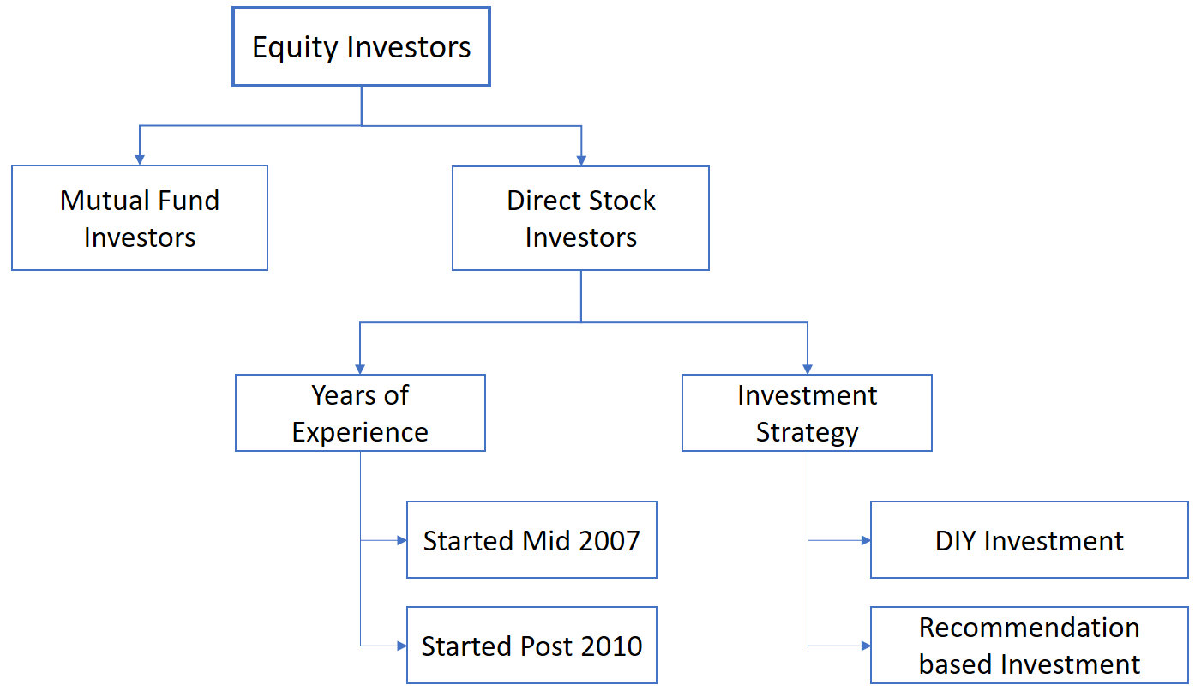

Years of Experience
I have considered Mid 2007 to evaluate the number of years of experience for an investor. This period being an inflection point in Indian markets (and also global markets to a great extend). It is from this time the markets started to gradually peak before being beaten back down from Jan 2008.
Investment Start | Primary aspect of this Investor group
Started Mid 2007 (and had been investing till now) | - 12+ years of experience  - Taken many lessons (and pains within a few months of starting) from 2008 meltdown, a few mentions:  - Basic caution not to take debt for stock investing  - Not trying to catch the bottom of a stock, every time the market falls – Key lesson that 2008 gave to investors  - Hold cash as one of the assets to utilize opportunities like 2008  - The should have developed an investment style, philosophy and strategy (A kind of a rule book) that suits them aligning to their risk calibre and lessons they had from 2008 carnage  - Basically, more risk conscious  - They have a pipeline of well researched, good-great companies through rigor analysis, but did not invest due to stretched valuation  - More aware and understand the importance of (1) Management Quality, (2) Valuation / Not overpay, in stock investment  - For them the current downturn is really an opportunity, which they witness post 2008 and may have been looking forward all these years
Started Post 2010  (and had been investing till now) | - They might have heard of 2008, but not witnessed or emotionally felt the downturn  - Experience < 10 years and primarily started seeing the boom from Mid 2009 or post 2013-14 rally in Indian stock markets  - They witness for the first time a shock of such magnitude i.e. Fall out of 2020  - So, the current situation could be emotionally taxing  - Risk conscious may be less than the above category  - May or may not have an investing strategy, even if there is one, it may not focus more on risk as in the case of above category  - Might not be in cash – Since they did not witness 2008 carnage, where markets gave great bargains but cash was not available to use it  - If they are not in cash, they would be struck and not able to use the opportunity in the coming days  - Even if in cash, they now doubt their picks, how long the situation would go, is it the time wait or invest?

Note: There are investors who started much before Mid 2007 i.e. 2000 or 2004. I have not covered that group for two reasons.
- There could be very few who are still in the game since they started i.e. 2000, and most them would are still in the game would be aware of the rules of the game as well as their own behaviour aspects
- Also, I started only from Jan 2008 and have been closely observing the market and investor behaviours from Mid-2007. I stick to what I have seen or felt.

Investing Strategy
Everyone I come across in a discussion or social media refer them self as Investors. Many have missed the difference between an investor or trader.
- A person who sticks to charts and buys and sells their holding the same day or within a few days, with an intention to gain from price movements, to be referred as Traders.
- A person who sticks to company fundamentals and buys fundamentally strong companies with an intention to gain from the future growth of the company and a holding period of a couple of years (Min. 5 to 8 years) can be termed Investors (Infact “Long Term Investors” would be the right term).
This is not to say that one approach is better than the other, but both have different rules and time horizon. Hence understanding this difference is crucial.
Among the investor category, DIY Investor is another common mention in Twitter handles. Does directly investing in stocks avoiding Mutual Funds qualify as DIY Investment? No. Who handles the process makes a difference? For a better clarity, bifurcation this into two categories here will help.
- DIY Investment: The investor is skilled enough and handles the investment process end-to-end, i.e. Screening, analysing, valuation and investing in stocks that are fundamentally strong. The conviction to invest in a stock is owned by them.
- Recommendations based Investment: The investor does not have the necessary skill sets (and/or time) and is primarily dependent on stock ideas from business channels, social media, friends or paid subscription. No own conviction on a stock idea, but based on conviction of other’s picks.
Own skill set and conviction is what differentiates the above two groups.
Note: In the discussion of “Years of Experience” and “Investment Strategy”, the definition is not meant to be rigid, but only a general overview. A few characteristics could be common between groups.

Pointers for DIY Investment
The below table has some pointers for DIY Investors who entirely do the investment process end to end. The below pointers are bifurcated based on “Years of Experience” discussed earlier.
Started Mid 2007 | Started Post 2010
- The investors NOW got the time, which they were looking for all these years after burning fingers in 2008  - Having a portion of their assets as cash to be deployed in such downturn/repeat of 2008  - They also have a ready list of investment ideas, which was researched earlier and could not buy due to high valuations  - Now is the right time to rollout 3Cs:  - Conviction (On your earlier researched ideas & Present holdings)  - Cash (Which you hold as part of your asset class for deploy during such downturn)  - Courage: That your pick and time is right, partly comes from Conviction  - Take caution not to forget the lessons of 2008  - Most importantly, Remember…  - This time will not the same as 2008 and recovery MAY take a longer time than 2008  - You may also get new lessons from this downturn  - The current downturn is not due to financial crisis, but a global humanitarian crisis which involves people life | - Such a big downturn was not anticipated  - Use the current situation to gauge your emotions i.e.  - Do you panic when market nose dives?  - Are you able to sleep well?  - Do you get doubt your own stock picks?  - Do you feel like seeing and waiting in cash or buy back the same stock at lower prices?  - Investment Strategy  - Did you have an Investment strategy in place?  - If Yes, Revisit to factor the learnings from this downturn  - If No, it is the best time to put one with your learnings from current downturn  - To stay clear of panic, revisit your investment thesis (If you have already created one!) or idea for “Why you brought the stocks in the first place?” to see, if still the story holds true  - If Yes, reassure yourself that investments will recover, but it may not happen immediately soon  - Cash Management  - If you are not in cash, stay calm and assured that recovery would happen but may not be soon – But don’t borrow to invest  - If you are in cash, invest more on companies that you already holding in your portfolio  - If you are in cash and have time to analyse, then pick a few fallen names

I have not mentioned anything for “Recommendation based Investment”, as the investment decision is primarily based on recommendation from others. There is not much to strategize, but be assured that this too will end. But when markets go up, your stocks also should go up. For this to happen ensure that the stocks in your portfolio are good/great companies that will bounce back with the markets.
One aspect that I did not touch upon in the above Matrix is, When is the right time to Invest?
As said in my Tweets, none have the answer. But a few pointers will help.
- Current situation has created a very big impact on Human Lives and Economy. Every government focus now is to save their people.
- There is lock down and quarantine in multiple parts of the globe, leading to a huge impact on economic activity. The size of the impact of the carnage can be accurately measured after situation is under control.
- There could be too many second order effects that we are not able to foresee at this stage. My guess is that setting the economy right would take time.
- It is not possible to fix a time by when the economy and stock markets could be back to normal. However, we can get some pointers from the below.
- Closely watch the current situation not only in India but across globe.
- Look out for the Q4 results (in case of Indian corporates), but Q1-2021 can give a better perspective as that quarter takes the full impact
- More importantly look out for the Annual Report for 2010-2020 (To be released by Indian companies in a few months) of your invested/target companies, which will outline the impact of current situation in the coming financial year

Thanks for Your Patience in this 5 Part Article. Good Luck.

